**REPORT ON**

**MICROSOFT AZURE FUNDAMENTALS**

|  |  |
| --- | --- |
| Name | Sakthi.K M |
| Register No | 710722104085 |
| Department | III B.E CSE |
| Date | 10.08.2024 |

**1)Sandbox:**

**Create a Linux virtual machine and install Nginx**

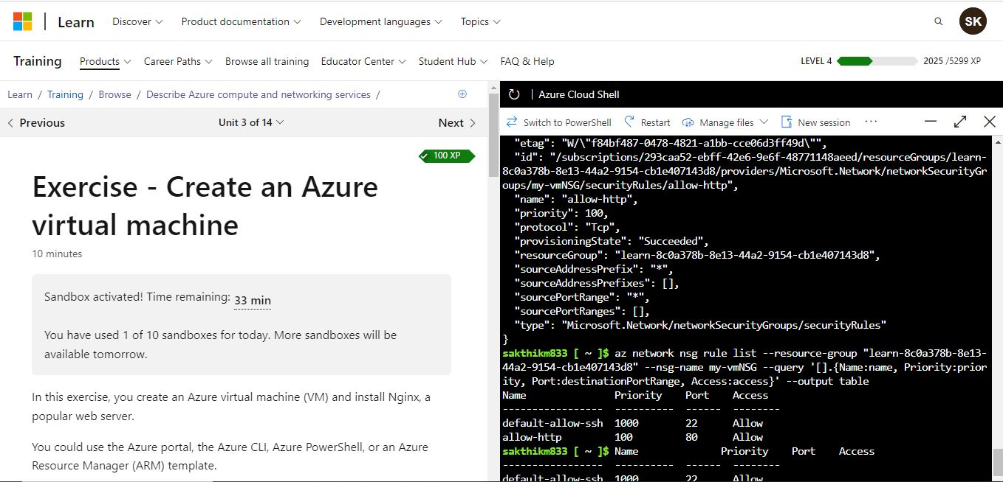

**Access your web server**

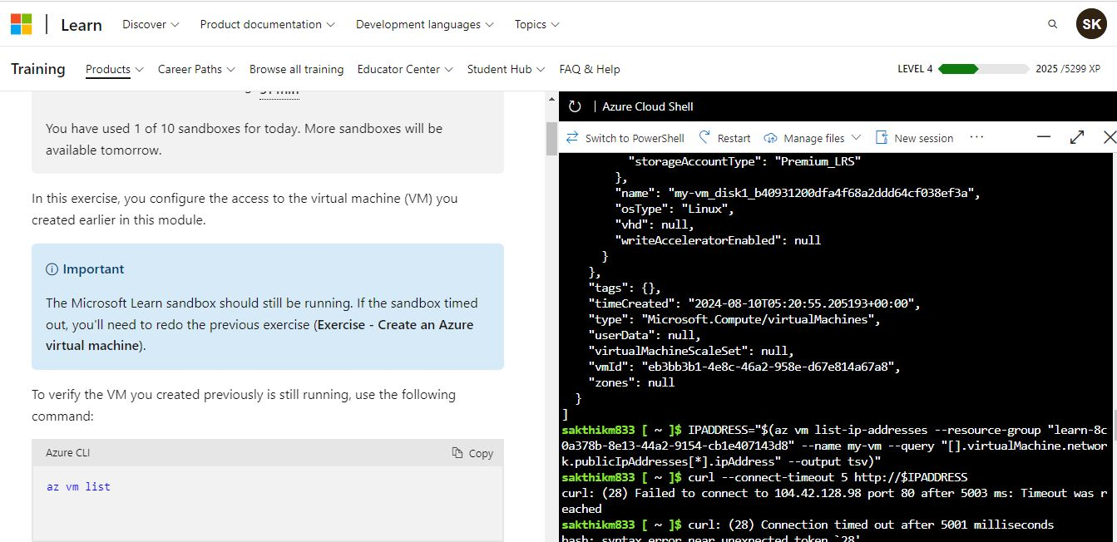

**List the current network security group rules**

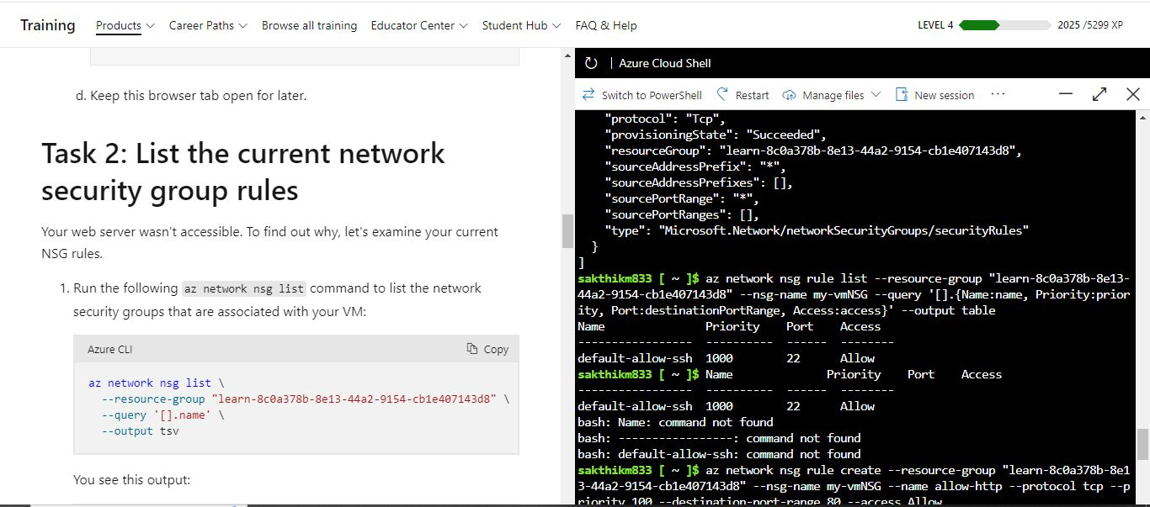

**Create the network security rule**

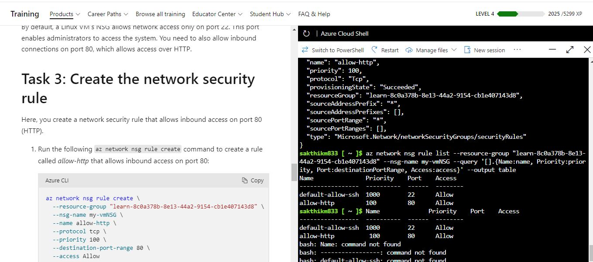

**Final output:**

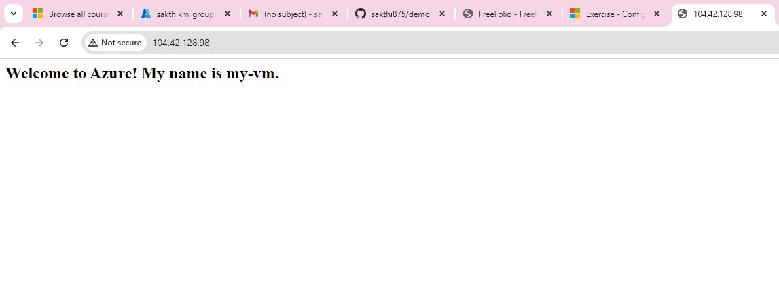

**2) Azure Academic Services: Azure for Students**

**BADGES**

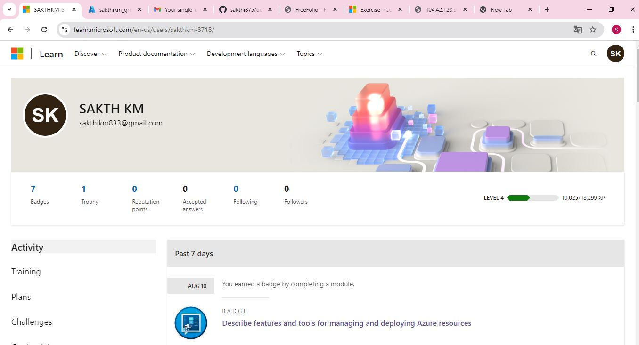

**Creation of resource groups**

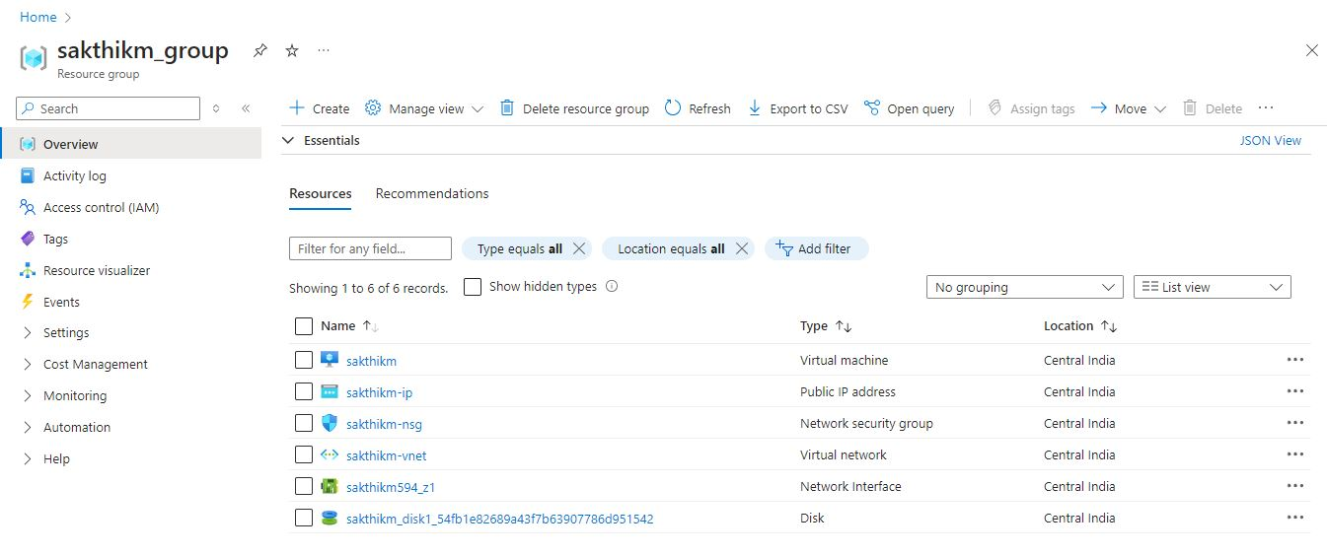

**Creation of Virtual Machine**

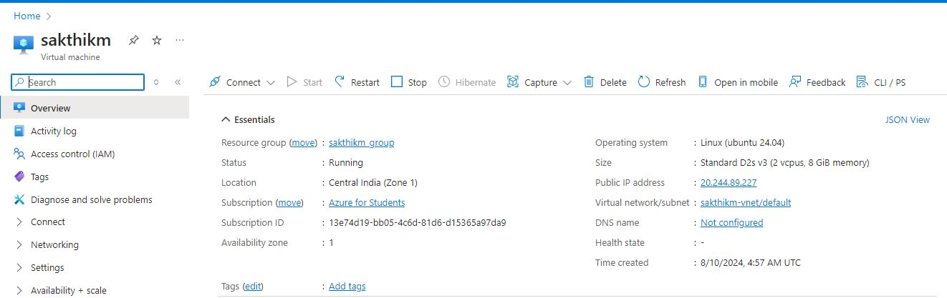

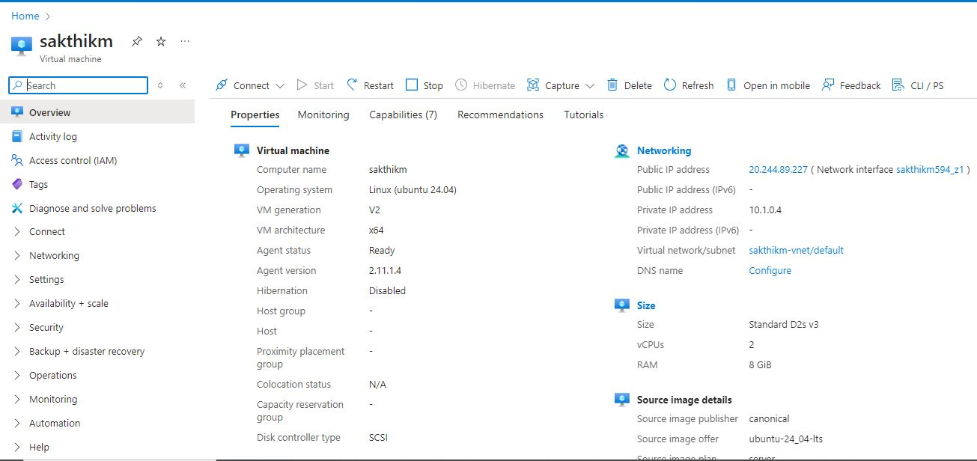

**Hosting my portfolio using Azure Cloud Services**

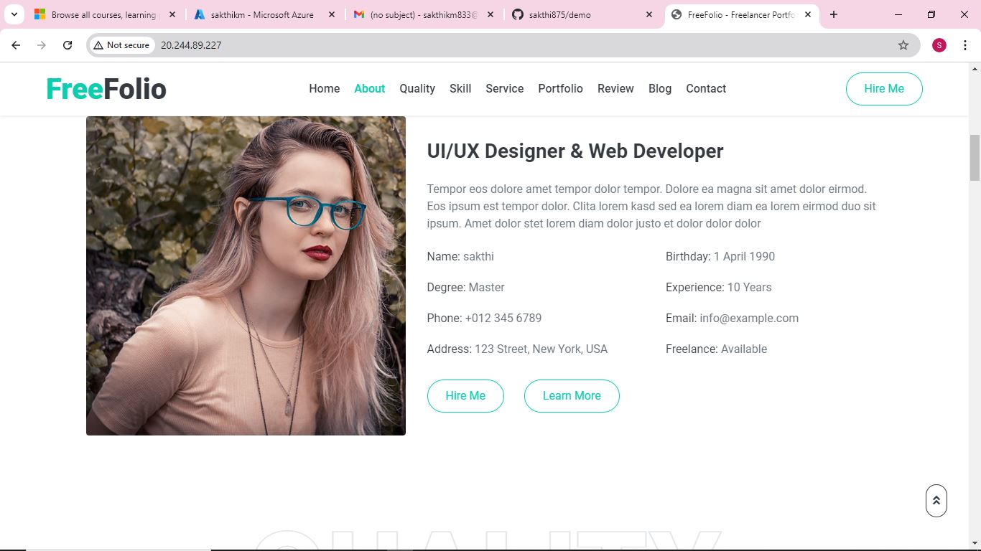

**Pricing calculator**

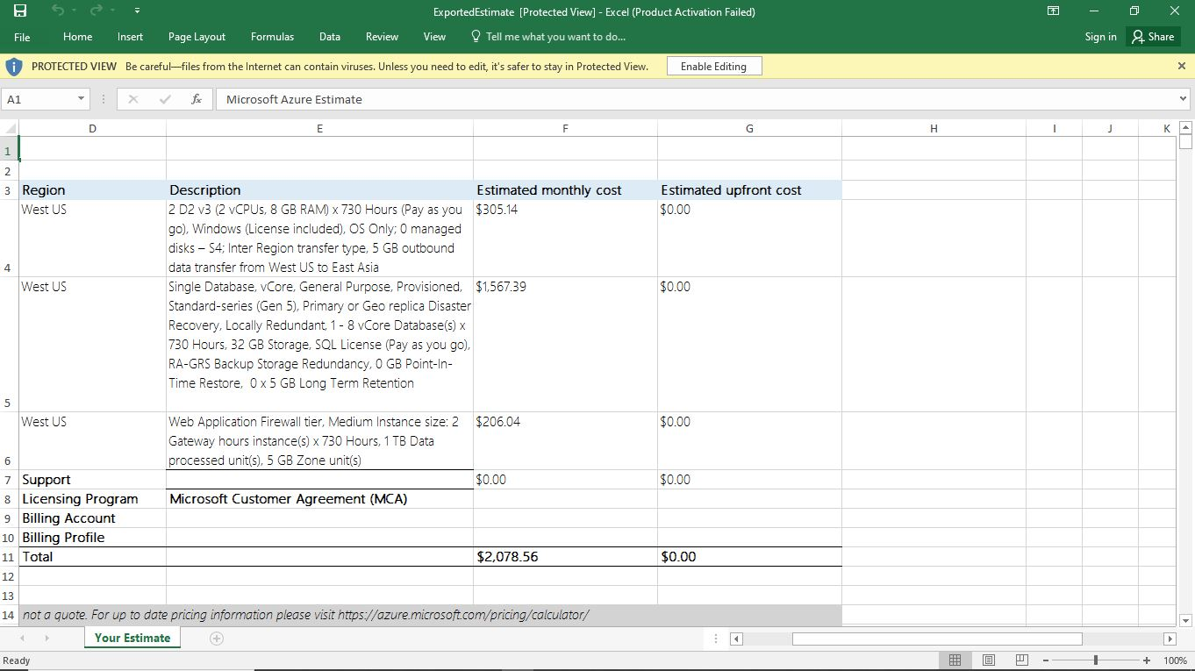

**Total Cost of Ownership (TCO) Calculator**

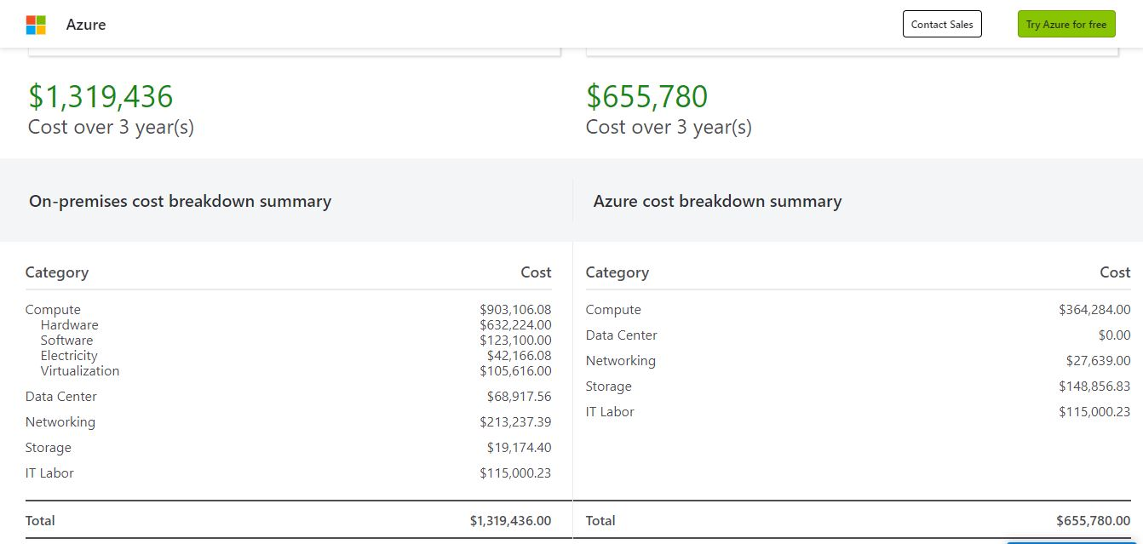

**Creation of container** 